John Short Racing by Jim Facey

T
he John Short big boat racing series was won by Jake Kelly as skipper of Joie De Vivre (J 105). It was an unusual series this year, with the 7 races won by 5 different boats. Another rare note, Gordon Fuller did not win a race for the first time in memory. Issues with his new boat, Patriot (Pearson 10M) limited him to only 3 races. Emerson Smith, sailing Smoke (B One) was the only skipper with multiple wins (3), but he did not sail the required 4 races to qualify for the series. Fifteen boats participated in the series overall, and seven qualified for series scoring. Rounding out the top 5 were in order: Mainestay VI (Hobie 33), Jim Coughlin; Irene (Knockabout 23), Bruce & Cathy Craven; Cahoots (J 30), Lindsay Huntoon & Craig Brigham; and Banshee (Ranger 29), Jim Facey.

Each year, the participating John Short racers vote to award the Don Knott Skipper of the Year prize to one of their number. The award is not necessarily given to the series winner, but to someone who best exemplifies sportsmanship and dedication to sailboat racing. For 2015, the racers voted for young Jake Kelly, who had a fine season as his first as the skipper for the Joie de Vivre syndicate.

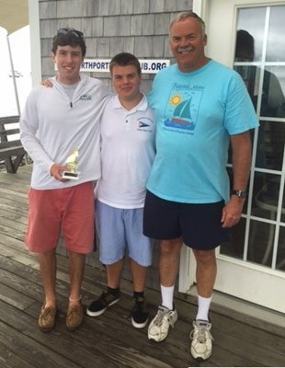
Above: Jake Kelly with Peter Knott, grandson of Don Knott, and Gordon Fuller.
Below: The winning crew rounds a mark.
John Short Qualifiers | Boat | Skipper | Best 4 Finishes
 | Joie de Vivre | Jake Kelly | 1 2 2 3
 | Mainestay | Jim Coughlin | 2 2 6 7
 | Irene | Bruce & Cathy Craven | 3 4 5 6
 | Cahoots | Huntoon & Brigham | 2 2 3 5
 | Banshee | Jim Facey | 1 2 4 4
 | Ceilidh | White & Lightner | 3 4 5 6
 | Skedaddle | Jon Linn | 8 8 7 9

John Short | 2015 Results
Boat | Skipper | Type | Race 1 | Race 2 | Race 3 | Race 4 | Race 5 | Race 6 | Race 7 | Total
Ceilidh | Lightner/White | Ranger 33 | 46 | 62 | 55 | 60 | 60 | 59 |  | 241
Irene | Craven | Custom |  | 52 | 52 | 63 | 70 | 73 |  | 258
Mainstay6 | Coughlin | Hobie 33 |  |  |  | 74 | 74 | 65 | 46 | 259
Patriot | Fuller | Pearson 10M |  |  |  |  | 63 | 63 | 52
Banshee | Facey | Ranger 29 | 54 | 58 | 58 | 66 | 58 | 53 | 66 | 248
Flyer | Ekborg | Beneteau | 40 | 50 | 48 | 52 | 52 | 61 | 49 | 215
Joie de Vivre | Kelly | J105 | 43 | 55 | 62 | 70 | 80 | 81 | 60 | 293
Avalon | Bradley |  |  |  |  |  |  | 67 | 56
Cahoots | Huntoon/Brigham | J30 | 50 | 66 | 66 | 56 | 56 | 70 |  | 258
Sea Tao | Frank |  | 60 |  |  |  |  | 77
Dart | Webster, D | double hull |  |  |  |  |  | 87
Skedaddle | Linn | boat |  | 48 | 50 | 58 | 54 |  |  | 210
Smoke | Smith | B/one |  | 72 | 72 | 80
Shockwaves | Morrow | Wavelength |  |  |  |  | 66 | 53 | 44
Carrousel | Lewton | boat |  |  |  | 54

